Detection of Life

The detection of life depends on finding bits of living things that are a tell-tale indication that life was present in an environment. These remnants could be bits of things currently living or the fossils of long-dead life.
Living things are made up of molecules and many of those molecules are unique to life. For example, although amino acids are found in the natural environment and sometimes have nothing to do with life, if we string them together we make proteins – long chains of amino acids. We do not know of any process other than life that makes proteins. So proteins are a signature of life. Other molecules that tell us there is life are long-chained sugars (carbohydrates) and nucleic acids such as DNA.
Over a long time, millions or even billions of years, many of these molecules are broken down by high temperatures and other environmental changes and the signatures of life are lost. However, some of these molecules can survive for a long time. Some molecules, such as hopanoids, which are molecules involved in making cell membranes, can survive for hundreds of millions of years. They can be extracted from rocks and by looking at the molecular structure of them scientists can tell what sorts of organisms they came from. This way ancient life can be studied.
Life can also leave other signatures. For example, the shapes of whole organisms can be preserved and these are the fossils with which we are all familiar, such as dinosaurs. However, even microbes can leave fossils and although they are very small (generally about a thousandth of a millimetre long) their shapes can be found in ancient rocks. Life can also leave chemical signatures. For example, life can separate different isotopes of elements (elements that have the same number of protons, but different numbers of neutrons). Life tends to prefer light isotopes. If we take carbon as an example, life will tend to be enriched in the light isotope of this element – Carbon 12 – compared to the heavier version – Carbon 13. So molecules in rocks that have more of the light isotope can sometimes be a signature of life.
Scientists can employ a number of these methods on the same samples of rocks, looking for molecules as well as any other chemical changes and shapes of microbes.
There are many complications with life detection. Just a few to think about are: 1) If rocks have been heated and pressurised in the rock cycle over millions of years, signatures might be destroyed, 2) Rocks could have been contaminated by more recent life, confounding efforts to find ancient life, 3) Non-biological processes might produce shapes that look like microbes or chemical changes such as isotope enrichments that are mistaken for life.
On the Earth, these methods are applied to looking for life in ancient Earth rocks, but they will also be applied to looking for life on other planets.

The Viking Landers, Mars
The first attempt to find life on another planet were the two Viking landers sent to Mars which had life detection experiments.
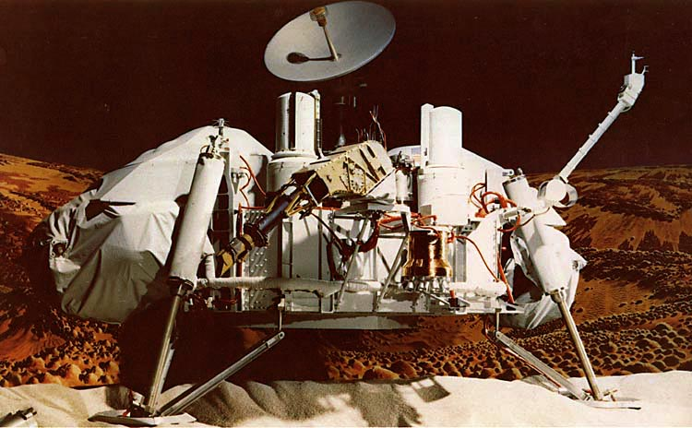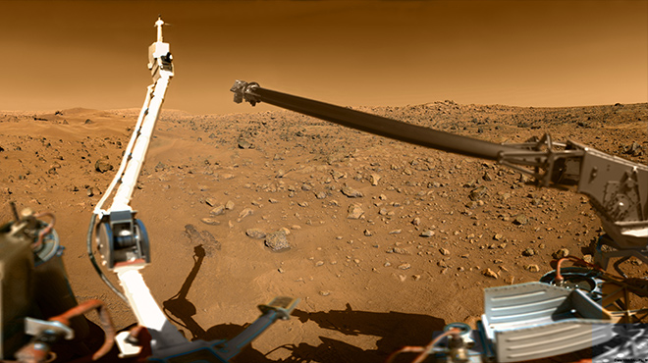
Figure. The Viking 1 lander on a simulated Martian background (left) and the Viking 2 lander on the surface of Mars in 1976.
These landers, sent by NASA had life detection experiments onboard. The experiments and the results were as follows:
1) A gas chromatograph — mass spectrometer (GCMS) is a device that separates vapour components chemically via a gas chromatograph and then feeds the result into a mass spectrometer, which measures the molecular weight of each chemical. As a result, it can separate, identify, and quantify a large number of different chemicals. It could measure molecules present at a level of a few parts per billion. The GCMS measured no significant amount of organic molecules in the Martian soil, suggesting no life.
2) The gas exchange (GEX) experiment looked for gases given off by an incubated soil sample by first replacing the Martian atmosphere with the inert gas Helium. It applied a liquid of organic and inorganic nutrients and supplements to a soil sample, first with just nutrients added, then with water added too. Periodically, the instrument sampled the atmosphere of the incubation chamber and used a gas chromatograph to measure the concentrations of several gases, including oxygen, CO₂, nitrogen, hydrogen, and methane. The scientists hypothesized that metabolizing organisms would either consume or release at least one of the gases being measured. The result was negative, suggesting no life.
3) The labeled release (LR) experiment gave the most promising results for life. In the experiment, a sample of Martian soil was inoculated with a drop of very dilute aqueous nutrient solution. The nutrients were tagged with radioactive carbon-14. The air above the soil was monitored for the evolution of radioactive ¹⁴CO₂ gas as evidence that microorganisms in the soil had metabolized one or more of the nutrients. The result was quite a surprise, considering the negative results of the first two tests, with a steady stream of radioactive gases being given off by the soil immediately following the first injection. The experiment was done by both Viking probes, the first using a sample from the surface exposed to sunlight and the second probe taking the sample from underneath a rock; both initial injections came back positive. Subsequent injections a week later did not, however, elicit the same reaction, which is not what is expected of life. Given more nutrients, life should multiply and produce more gas. The explanation is that the Martian soil contains powerful oxidants such as perchlorates and hydrogen peroxide. These chemicals broke down the nutrients and released gases, but once they were all used up they stopped being effective, explaining why the gas production ceased.
4) The pyrolytic release (PR) experiment consisted of using light, water, and a carbon-containing atmosphere of carbon monoxide (CO) and carbon dioxide (CO₂), simulating that on Mars. The carbon-bearing gases were made with radioactive carbon-14. If there were photosynthetic organisms present, it was believed that they would incorporate some of the carbon as biomass through the process of carbon fixation, just as plants and cyanobacteria on Earth do. After several days of incubation, the experiment removed the gases, baked the remaining soil at 650 °C, and collected the products in a device which counted radioactivity. If any of the carbon had been converted to biomass, it would be vaporized during heating and the radioactivity counter would detect it as evidence for life. Should a positive response be obtained, a duplicate sample of the same soil would be heated to "sterilize" it. It would then be tested as a control and should it still show activity similar to the first response, that was evidence that the activity was chemical in nature. However, a nil, or greatly diminished response, was evidence for biology. This same control was to be used for any of the three life detection experiments that showed a positive initial result. The data showed that fixation of atmospheric carbon occurs in the surface material of Mars. Although the amount of material was small relative to that which organisms on Earth produced, it was still more significant than the margin of error and could have been evidence for life. Although the results are not fully understood, along side the other experiments the suggestion is that chemical reactions in the Martian soil fixed some of the carbon dioxide gas into organic carbon.
The Viking experiments are a classic lesson in science since they show that some of the results looked biological. It was necessary to repeat the experiments and to have multiple experiments to rule out a biological explanation. Today, the results are widely believed to show active chemical compounds in the Martian soil such as powerful oxidants, an idea supported by the discovery of these oxidants by independent observations on other missions.

Life in Martian meteorites?
Scientists have also attempted to find life in Martian meteorites. Allan Hills 84001 (commonly abbreviated ALH84001) is a meteorite that was found in Allan Hills, Antarctica on December 27, 1984, by a team of U.S. meteorite hunters. ALH84001 is thought to be from Mars. The meteorite is best known for gaining intense media attention in 1996 when a group of scientists claimed to have found evidence for microscopic fossils of Martian bacteria in it, culminating in then U.S. president Bill Clinton giving a speech about the potential discovery. Under the scanning electron microscope structures were revealed that some scientists interpreted as fossils of bacteria-like lifeforms. The structures found on ALH84001 are 20–100 nanometres in diameter, but smaller than any cellular life known at the time of their discovery. If the structures had been fossilized lifeforms, they would have been the first solid evidence of the existence of extraterrestrial life. These claims were controversial from the beginning, and the wider scientific community ultimately rejected the hypothesis once all the unusual features in the meteorite had been explained without requiring life to be present.
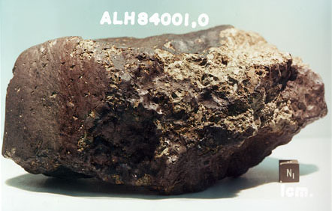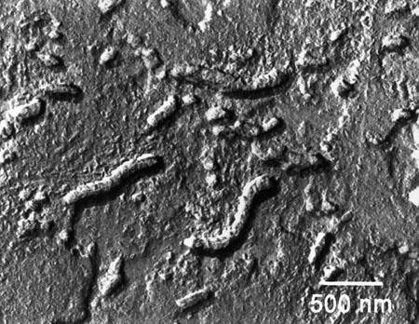
Figure. Martian meteorite ALH84001 (left) and the claimed martian fossils on the right.

