MERCURY  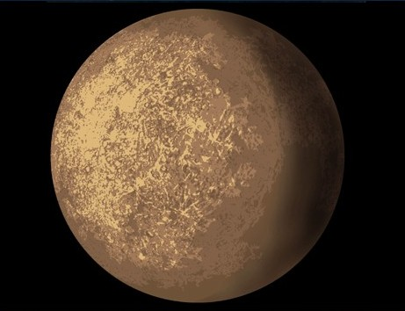  Temperature: 427 °C  Distance from Sun: 56.9 Million Km  Diameter: 4878Km  Gravity Compared to Earth: 0.38  Year of Discovery: 1885  Rotation Time: 58.7 Earth Days  Orbit Time: 88.0 Earth Days | VENUS  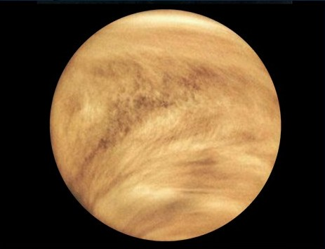  Temperature: 482 °C  Distance from Sun: 108.2 Million Km  Diameter: 12104Km  Gravity Compared to Earth: 0.90  Year of Discovery: 1990  Rotation Time: 243 Earth Days  Orbit Time: 224.7 Earth Days | EARTH  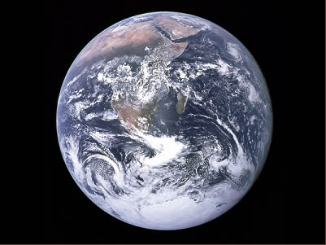  Temperature: 15 °C  Distance from Sun: 149.6 Million Km  Diameter: 12756Km  Gravity Compared to Earth: 1.0  Year of Discovery: n/a  Rotation Time: 1 Earth Day  Orbit Time: 365.25 Earth Days
MARS  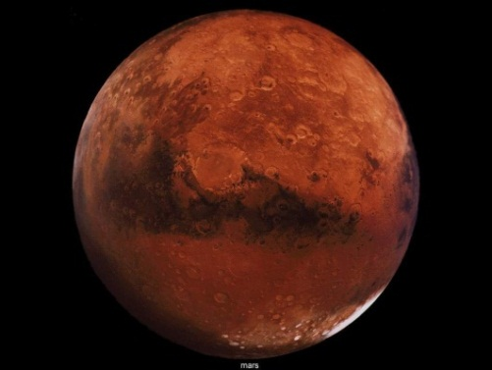  Temperature: -23 °C  Distance from Sun: 227.9 Million Km  Diameter: 6794Km  Gravity Compared to Earth: 0.38  Year of Discovery: 1580  Rotation Time: 24.6 Hours  Orbit Time: 687.0 Earth Days | JUPITER  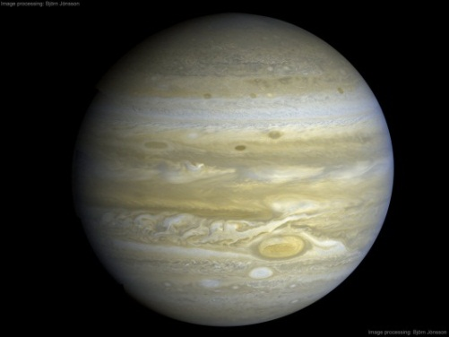  Temperature: -150 °C  Distance from Sun: 778 Million Km  Diameter: 142,800Km  Gravity Compared to Earth: 2.3  Year of Discovery: 1610  Rotation Time: 9.84 Hours  Orbit Time: 4332 Earth Days | SATURN  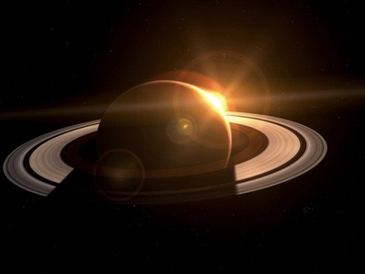  Temperature: -180 °C  Distance from Sun: 1427 Million Km  Diameter: 120536Km  Gravity Compared to Earth: 1.16  Year of Discovery: 700BC  Rotation Time: 10.2 Hours  Orbit Time: 10760 Earth Days
URANUS  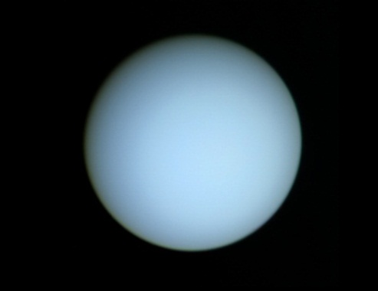  Temperature: -214 °C  Distance from Sun: 2870 Million Km  Diameter: 51118Km  Gravity Compared to Earth: 1.17  Year of Discovery: 1781  Rotation Time: 17.9 Hours  Orbit Time: 30700 Earth Days | NEPTUNE  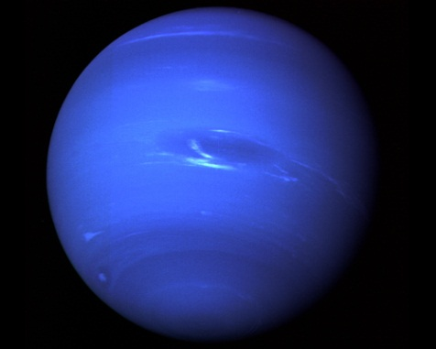  Temperature: -220 °C  Distance from Sun: 4497 Million Km  Diameter: 50538Km  Gravity Compared to Earth: 1.77  Year of Discovery: 1846  Rotation Time: 19.1 Hours  Orbit Time: 60200 Earth Days | PLUTO  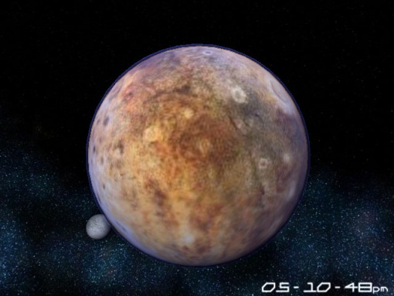  Temperature: -230 °C  Distance from Sun: 5900 Million Km  Diameter: 2324KM  Gravity Compared to Earth: 0.06  Year of Discovery: 1930  Rotation Time: 6.39 Earth Days  Orbit Time: 90600 Earth Days

