Telescopes

What is a telescope and how do they work?

A telescope is an instrument used to see objects that are far away, such as stars and planets. They can be found on the ground or even in space!

The two main properties of telescopes are light gathering ability and magnification. The better a telescope can gather light, the better you will be able to see far away stars and faint objects in the night sky. This feature is usually determined by the size of the aperture, the diameter of the main lens or mirror of the telescope. The larger the aperture, the more light the telescope can gather. The magnification of a telescope describes how much larger the telescope can make objects appear.

There are two main types of telescopes. One uses a big parabolic mirror (called a reflecting telescope), and the other one uses collecting lenses (called a refracting telescope).

Refracting telescopes

A refracting telescope works bending light through a lens so that it forms an image. There are a few problems with refracting telescopes:

- Some of the light reflects off the lens so the image is very faint
- Large lenses are needed to improve the magnification – this can be difficult to do perfectly.

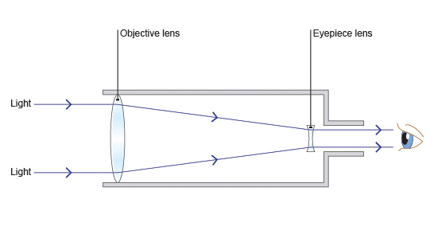

Reflecting telescopes

Reflecting telescopes use mirrors instead of lenses to focus the light. A curved mirror is used to gather light and reflect it back to a focal point. In order to get the light out of the telescope, a secondary mirror is used to direct the light to an eyepiece. There are various designs of reflecting telescopes, but the original design by Isaac Newton is still popular today.
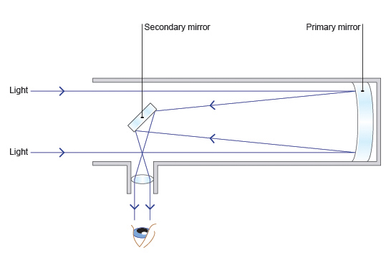
Telescopes in Space

Not all telescopes use visible (optical) light to observe distant objects. Some of the telescopes in space use infrared light to see cooler, distant objects in space. This is at longer wavelengths and can be seen in the diagram below:

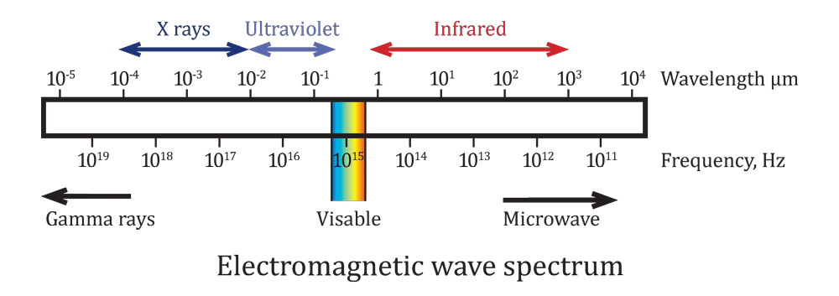

An example of such a telescope is the James Webb Space Telescope (JWST), due to launch in 2019, which will use infrared light to look at the first stars and galaxies in our universe. It will also be used to study the properties of planets around other stars, including looking for the signature of water in their atmosphere.

JWST has a sun-shield the size of a tennis court, which is used to keep the telescope and its instruments permanently in the shade where they will cool down to -233ºC.
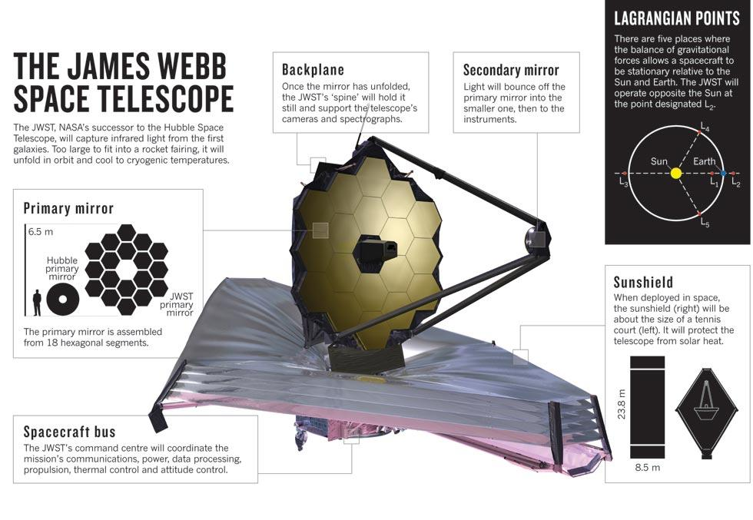
James Webb Space Telescope – Extra links

Make a model of JWST

https://jwst.nasa.gov/papermodel_swales.html

NASA JWST ‘Fun Pad’

https://jwst.nasa.gov/education/JWSTScienceFunPad4-6-11.pdf

JWST Colouring page

https://jwst.nasa.gov/education/D1899JWSTcoloringpage.pdf

Online Flash Game Comparing Hubble and JWST

https://jwst.nasa.gov/scope.html

Interpreting Infrared

Royal Observatory Edinburgh Thermal Camera for loan?

Classroom activities about infrared light

https://www.sofia.usra.edu/sites/default/files/activeAstronomy.pdf

A timeline of the telescope

The 1600s

1608 - Hans Lippershey, a German-Dutch lensmaker once said that he wanted to make an instrument “for seeing things far away as they were nearby.” He was the first person to ever think of the telescope.

1609 - On hearing about this new instrument, Italian physicist Galileo Galilei builds his own. He improved Lippershey’s design and using his new telescope the following year, he discovers the four largest moons of Jupiter (Io, Ganymede, Callisto and Europa), sunspots on the surface of the Sun, the phases of Venus and physical features on the Moon - such as craters!

1616 - Italian priest and astronomer Niccolo Zucchi creates a concave spherical mirror (a mirror that bulges inwards - very much like a cave!) to magnify objects and he used it to discover Jupiter’s belts 14 years later.

1630 - German priest and astronomer Christoph Scheiner builds a telescope based on a design that astronomer Johannes Kepler made in 1611. Kepler’s design improves on Galileo’s by replacing the concave lens with a convex lens (a lens that bulges outwards). This helped to reduce spherical aberration. Astronomers find spherical aberration quite annoying as it means that they do not get perfect images when they look through their telescopes. Imagine having distorted vision!

1655 - Christian Huygens looks through his aerial telescope Inspired by the observations of Jupiter made by Galileo, Dutch astronomer Christian Huygens builds the most powerful telescope ever and uses it to view the planets in our Solar System. He spotted a bright moon in orbit around Saturn and called it “Saturni Luna.” All astronomers used this name until 1847 when John Herschel (famous astronomer William Herschel’s son) decided that the moon should be called Titan. Huygens studied Saturn much more with his telescope and discovered the true shape of the planet’s rings in 1659.

1666 - After studying the reflection of light through prisms, Sir Isaac Newton decides that the problem of chromatic aberration cannot be solved. He makes an improved version of the reflecting telescope.

1672 - Laurent Cassegrain, a catholic priest from France, develops a telescope that bears his name - the Cassegrain telescope. This instrument uses mirrors that are called hyperbolic and parabolic mirrors.

The 1700s

1721 - English mathematician (and inventor of the octant) John Hadley present a much-improved Newtonian telescope design.

1729 - A huge development in refracting telescope happens during this time when lawyer Chester Moore Hall makes a lens to reduce chromatic aberration even further. He made the lens by cementing two types of glass (crown and flint) together. He proved that Newton’s statement that chromatic aberration could not be solved was incorrect!

1789 - William Herschel's 40 foot telescope - Bath (UK) Orchestra Director and astronomer William Herschel builds a Newtonian based reflector telescope which is a gigantic 12-metres. It was the first of the giant reflector telescopes.

The 1800s

1845 - The “Leviathan of Parsonstown” at Birr Castle in Ireland was built in this year by the Third Earl of Rosse, William Parsons. It was the largest telescope ever built until the twentieth century. Parsons was the first person to see spiral arms on a galaxy!

1897 - American astronomer Alvan Clark builds the world’s largest (at that time!) existing refracting telescope - the Yerkes Telescope in Wisconsin. Because this telescope holds the largest glass lens possible before a telescope will begin to buckle under its own weight, astronomers decided that large telescopes should have mirrors instead of lenses.

The 1900s

1937 - Inspired by sky survey work by Karl Jansky, American engineer Grote Reber takes the telescope into a whole new dimension: the radio telescope. Reber created an instrument that could basically see radio waves - waves that are invisible to our eyes.

1957 - Astronomer Sir Bernard Lovell planned a 250ft radio telescope that could be pointed to anywhere in the sky in the 1950s. After a series of technical and financial problems, it was finally built and ready to be used in the summer of 1957. The telescope can be visited at Jodrell Bank in the UK.

1990 - NASA and ESA’s Hubble Space Telescope, the first telescope to be launched into space. Above the turbulence of the Earth’s atmosphere, Hubble gives us a very clear view of the stars and planets right to this very day!

1991 - The Compton Gamma Ray Observatory becomes the first space telescope to look at objects that belch out high energy waves called gamma rays.

1995 - The W. M. Keck Observatory, a two-telescope astronomical observatory, is built near the summit of Mauna Kea in Hawaii at an incredibly dizzy height of 13,600 feet. They are the second largest optical telescopes in the world.

The 2000s

2009 - The Herschel Space Observatory is launched. Bearing the name of astronomer, William Herschel, this space observatory is able to look into the really cold regions of space with its far infrared vision!

2010 - The brand new and very large telescope in the Canary Islands. The Gran Telescopio Canarias is built on the island La Palma in the Canary Islands of Spain on the top of a volcanic peak 7,438 feet above sea level. It is the largest telescope of our time.

2019 – Launch of the James Webb Space Telescope!

2024 - European Extremely Large Telescope (Chile) - The E-ELT will be the largest telescope on Earth, boasting a main mirror that stretches 39 meters across. Its mirror will be composed of 798 hexagons measuring 1.4 meters each. It will collect 13 times more light than today's telescopes, helping it scour the skies for hints of exoplanets, dark energy and other elusive mysteries.

