What is Habitability?
The word habitat comes from the Latin ‘habitare’ to live and translates as ‘it lives’. Understanding habitability not only based in biology and physics but is also an exercise in philosophy, at least until we understand the limits of life completely (or find life on other planets!). Habitability is relative to the organism. We therefore define a habitat as an environment that has the conditions for an organism to be active. When we think of habitability we often think of large organisms (like ourselves) and whether we would be able to live there. There are some places on the Earth that we would describe as not very habitable or even uninhabitable for humans, such as the bottom of the ocean, on the very top of Mount Everest, in Antarctica, under glaciers, in deserts etc. - But in some of these environments we know so many other organisms can live.
As Astrobiologists, we study habitability as it relates to microorganisms as they occupy the extreme edges of our biosphere – we call these organisms Extremophiles. We know microbes can survive temperatures of 122°C around deep sea hydrothermal vents and can survive in ice at -20°C. Some can survive desiccation (being dried out) and some can survive on the outside of space craft. One of the biggest problems in studying extremophiles is finding them. If we take the same organism that likes to grow at 121C and place it at room temperature (~20C) it will almost certainly die so for this organism room temperature is extreme - so what does extreme really mean really? We can see that the limits of the biosphere are broad and not limited to conditions on the surface. We see the Earth as habitable because everywhere we look it is covered in life. If we were to look at Mars would we say the same? Globally we may say Mars looks uninhabitable (it’s dry, there’s no atmosphere and it’s bombarded by Ultra-violet radiation etc.) but locally we may find areas or niches where microbial life can survive. For example, in the subsurface around the equator there may be liquid water beneath the surface, in caves below the surface, or even in the past. So, habitability varies not just spatially but also temporally (in-time).
If we can see that conditions on Earth are common (or not) and where and importantly how life can survive under extremes then this will help in our search for habitable planets and in our understanding in the conditions necessary for the origins of life. Ideally, it would be best to explore every planet to understand their conditions, but resources are limited. Therefore, we need to pick the best possible candidates for exploration which is based on our understanding on the limits of life as we know it.

Why is the Earth Habitable?
The understanding of habitability hinges on our understanding of the origins of life. Will life develop anywhere the conditions are right? Or can habitats be habitable but uninhabited (a right mouthful!) – for example an abandoned house may have the conditions for someone to live in it but doesn’t mean there will be someone there. If we look at the Earth today it’s difficult to say why it is habitable, we can certainly explain why conditions are the way they are but we know that conditions on Earth change all the time and when we look at the history of the Earth and the history of life we can see that they are intimately linked. Has life evolved to fit Earth? Or has Earth evolved to suit life?
The interconnectedness of Earth and Life is the principle idea in the Gaia Hypothesis. For example, oxygen is produced biologically through photosynthesis. In Earth’s early history oxygen was not a major gas and CO2 was. Once photosynthesis evolved organisms could generate energy from sunlight and CO2 and oxygen was generated as a waste product. CO2 is controlled by plate tectonics and the weathering of rocks and biology. Today oxygen is a major gas and CO2 is a minor gas and both gases are regulated by complicated global cycles involving biological and non-biological processes. The presence of CO2 also regulates the temperature of the planet through the greenhouse effect. So perhaps the Earth is more habitable due to the presence of life. For microbes, habitability is mainly controlled by local and microscale processes which are not as easy to predict from average global conditions (for example it’s hard to say what the conditions are under the surface of the Martian equator from just looking at the average temperature of the planet).

Below is a list of factors that have contributed to the Earth being a habitable place. As you read them you may begin to realise that they are all very much linked to each other in their development. This highlights the complications in assessing the critical conditions necessary for life.

Factors

The Habitable Zone
One of the basic ways of assessing habitability is using the Habitable Zone. This is the zone around a star where liquid water is stable. This can be described as the ‘Goldilocks Zone’ where the planet is the right distance from the sun – not too hot, not too cold. The surface temperature of the planet is very important for habitability – all life on Earth needs water to survive. One of the main criteria is if liquid water is stable on the surface of the planet. If water is too cold it will freeze, if it’s too hot it will evaporate. We call the outer edge the ‘frost’ or ‘snow’ line. If we know the temperature of a star we can calculate the area around the star where it’s too cold and where its’ too hot.
The habitable zone in our solar system. The dark green zone is the band where liquid water would be stable on a planet’s surface. Source: Charles Cockell
The surface temperature is not only related to the temperature of the star but also on the presence of an atmosphere. On Earth, we’ve heard of the greenhouse effect, whereby gases in the atmosphere trap incoming solar radiation. This effect occurs on other planets too. The effect of this is that if a planet has a thick atmosphere, it can be further away from the sun and still have liquid water on its surface - like wearing a coat allows you to stay warm when it’s cold outside.
Similarly, we know of icy moons beyond the habitable zone where the surface is frozen but liquid water may exist. So, it’s not just as simple as being the right distance from a star, but knowing about this zone does make it easier when we look for potential habitable exoplanets.

Water
One of NASA’s guiding policies is ‘Follow the Water’. Water is made up of Hydrogen and Oxygen, two of the most abundant elements in the Universe. All life on Earth needs liquid water to survive and is often referred to as the ‘Universal Solvent’, so it makes sense when we are exploring other planets, to look for places where water exists or has existed in the past. We’ve already mentioned that the surface temperature has important implications for the stability of water. One of the complications is the phase that water is in. On Earth, due to the distance from the sun, water exists in all three phases (Solid, Liquid and Gas). On other planets, it gets a bit more complicated. On the icy moons, Enceladus (Saturn) and Europa (Jupiter), the surface is frozen at temperatures around -200C! They exist beyond the frost line but scientists believe that below their frozen crusts there may be liquid water oceans.

Energy
One of the other requirements for life is energy. Without energy, nothing can happen. Life on earth all requires certain elements – Carbon, Hydrogen, Nitrogen, Phosphorous, and Sulfur – we call these the CHNOPS elements or macronutrients. All organisms on Earth are carbon based and we know that carbon is found throughout the universe and isn’t a ‘rare’ element – for example Carbonaceous Chondrites are carbon rich meteorites but this organic matter does not come from life.
On Earth if there is a chemical reaction that generates energy, then there is probably an organism that exploits it. Most organisms survive directly or indirectly from the energy produced by our sun (whether its plants using photosynthesis or an animal eating those plants). However, we know of many microorganisms that survive in absence of light (such as in the deep ocean or deep underground). In these environments, life can generate energy from minerals in rocks (Lithotrophs) or from inorganic compounds (Chemolithotrophs) and these are the kinds of metabolisms we may expect to find in the more extreme environments of our solar system and beyond.

Size
The size of the planet is also very important, if a planet is too big, it will grow until it becomes a gas giant. If it’s too small it won’t have enough gravity to keep its atmosphere. The size of the planet also will influence its internal heat, with larger planets generally having hotter interiors. For smaller planets, they cool and lose their ability to initiate plate tectonics. When there’s enough heat, convection begins which in turn can lead to plate tectonics. Larger ‘Super Earths’ may have faster plate tectonics, resulting in faster mountain building and subduction which consequently may result in higher mountains and more volcanism! On Earth, it appears that the conditions were just right for the initiation of plate tectonics and the generation of a dynamo, both of which have contributed to the habitability. There is also a theory that the presence of water can act to ‘lubricate’ subduction (a component in plate tectonics) that makes it easier for plate tectonics to start. So perhaps liquid water is also critical for plate tectonics.
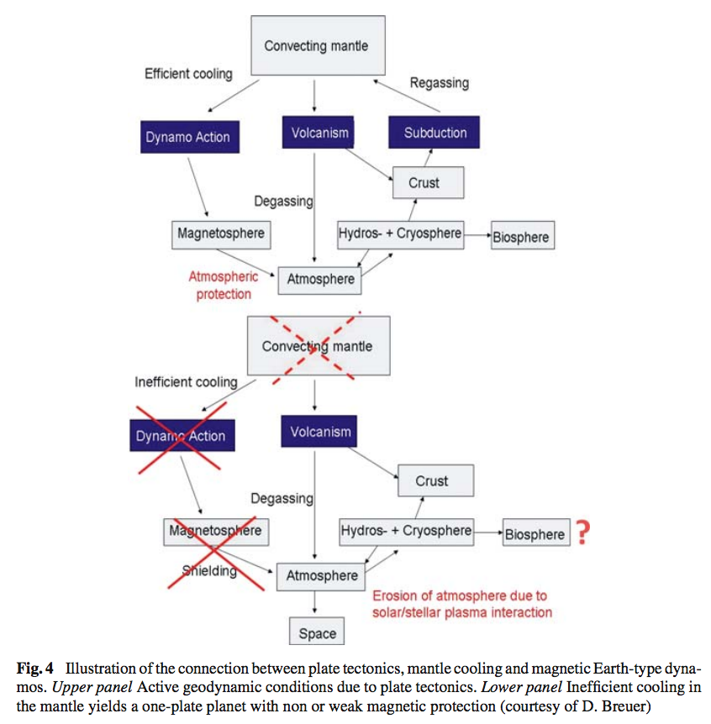
An illustration of the connection between plate tectonics, cooling of the mantle and the magnetosphere.
This may be a bit more in depth than necessary but it shows the links between mantle processes and how they have led to the conditions currently on Earth. (Taken from Lammer et al. [2009] – What make a planet habitable?).

Plate Tectonics
Plate tectonics is the process of large scale movement of plates on the surface of the Earth. Its related to convection within the mantle of the Earth. One consequence of plate tectonics is subduction and volcanism. This allows the recycling of the crust over millions of years and allows the recycling of elements over geological timescales. Plate tectonics also result in the release of gases to the atmosphere and can aid in generating and sustaining a planet’s atmosphere. Atmospheric CO2 and the carbon cycle is regulated by processes within plate tectonics and active volcanism can lead to a denser atmosphere. Plate tectonics also leads to efficient heat transport and indicates that there is convection in the mantle. Maybe plate tectonics an indicator of other conditions but certainly the effects have contributed to the current conditions on Earth.
From Wikipedia – Mantle Convection

Magnetic Fields
Planetary magnetic fields have poles and can attract and repel particles that are charged. Earth’s magnetic field is believed to be generated by conductive fluids that flow around the rotating inner core. This flow generates a magnetic field. A magnetosphere, protects the planet’s atmosphere and the surface from charged solar wind and radiation. Without a magnetic field, the Earth would be exposed to solar winds which attack the atmosphere and sputter it over time (gradually blowing it away).
It may important for the habitability for a planet to have a magnetic field early after formation as younger stars tend to eject more energetic material. A magnetic field therefore acts as a shield to early prebiotic chemistry/or early evolution of life and we may define as necessary to make a planet habitable. If we compare Earth and Mars, one of the main differences is that Mars lost its magnetic field very early on in its history. Consequently, its atmosphere was exposed to solar winds, which resulted in its erosion and thinning of the atmosphere. The surface is also bombarded by ultraviolet radiation (which doesn’t happen on Earth due to the presence of Ozone).

An Atmosphere
An atmosphere increases the pressure at the surface due to the weight of the air. Without atmospheric pressure liquid water would not be stable, and without liquid water life may not have evolved. Atmospheres are also involved in trapping heat through the greenhouse effect and provide gases for chemical reactions.
Earth has always had an atmosphere however over geological timescales its composition has changed. The first atmosphere was likely dominated by CO₂ with oxygen being a trace gas – however today it’s a major component and is vital for all aerobic organisms (including ourselves!). The first organisms were likely anaerobes, these are organisms that survive without oxygen. The necessary composition of an atmosphere is less certain, as oxygen is certainly not necessary for life but its use has certainly has given life an ‘evolutionary boost’. An atmosphere may not be totally necessary for life - again looking at the moons Enceladus and Europa, they do not have substantial atmospheres but may have liquid water oceans that are considered habitable.

A moon
It is speculated that the moon plays a role in a planets habitability. Some models suggest that the moon acts to stabilise the tilt of the Earth which in turn affects the planets climate.

Time
One of the more complicated components to the origins of life and habitability is time. If a habitable environment doesn’t exist for long enough then perhaps there’s not enough time for life to develop. Life on Earth has taken at least 3.5 billion years to develop. The first billion years of Earth’s history the Earth may have been uninhabited – which is an incredibly long time. Mars was perhaps habitable for its first billion years and then became the wasteland that exists today. When we look at our solar system and exoplanets today, we are seeing a snapshot of their history.
Environments also change. Scotland hasn’t always been at the same point on the face of the Earth. Scotland, has gone from being at the bottom of an ocean during the Cambrian (541-485 Million years ago), to being a desert during the Triassic (252-201 Million Years ago), to having many volcanoes during the Palaeogene (66-2.6 Million Years ago). Over millions of years, the life that inhabited Scotland would have changed, and many places would have become uninhabitable for the organisms that lived there. While these changes probably weren’t as extreme as on Mars, the idea is the same. When we look at mars we can see its dry, cold and probably not very habitable. In its history, just as in the Earth’s history, the environment would have been very different. On Mars, it is believed that it would have been warmer and wetter with oceans and a thicker atmosphere. Currently the NASA Curiosity Rover is examining Gale Crater, that used to be a lake 3.5 Billion years ago!).
Another component of time is the direction of evolution. The evolution of a planets environments occurs over time. Maybe the current limits of our biosphere are more linked to the progress of evolution than due to any limits in biology or physics. If the change is sudden, maybe life doesn’t have time to adapt to the extreme, if its gradual the case may be different.

For More info on Scotland’s environmental and geological history –
http://www.scottishgeology.com/geo/geological-time-scale/

Climate Change on Earth and in our Solar system.

As explained above, the gases in a planet’s atmosphere will affect the temperature of the planet’s surface. This is one of the basic components of how we understand climate change on Earth. We can also see this effect on other planets for example on Venus, the atmosphere is 96.5% Carbon dioxide, 3.5% Nitrogen and contains traces of other gases including Sulfur Dioxide. The atmosphere of Venus is incredibly dense which makes the pressure on the surface much higher than on Earth at about 90 times greater! This is the equivalent as if you were 900m under water on Earth. Due to the dense atmosphere and the high CO2 concentration, which we know is a greenhouse gas, the greenhouse effect is incredibly intense on the surface. Temperatures on Venus reach 450-500 degrees Celsius! This is way hotter than your kitchen oven or hob can go. This makes it difficult to send rovers to Venus because the electronics melt. The greenhouse effect is why Venus is the hottest planet in our Solar system and not Mercury (which is the closest to the sun).

ONLINE RESOURCES

Astrobiology Primer
http://online.liebertpub.com/doi/pdf/10.1089/ast.2015.1460

Free NASA Astrobiology Graphic Novels
https://astrobiology.nasa.gov/resources/graphic-histories/

What Makes a Planet Habitable? – Lammer et al. 2009
https://web.archive.org/web/20160602235333/http://veilnebula.jorgejohnson.me/uploads/3/5/8/7/3587678/lammer_et_al_2009_astron_astro_rev-4.pdf

BBC – What makes a planet habitable
http://www.bbc.co.uk/news/science-environment-33929851

What Makes a planet habitable – Cockell
https://www.youtube.com/watch?v=t_8ES2cQsnE

Habitability Cards – NASA
https://nai.nasa.gov/media/medialibrary/2016/01/Astrobiology-Habitability-Cards.pdf

Ted Talk – What a planet needs to sustain life – Dave Brain
https://www.youtube.com/watch?v=9RTkZaX1cH0

NASA Astrobiology Institute Class Room Materials
https://astrobiology.nasa.gov/classroom-materials/

Fermi Paradox
https://www.youtube.com/watch?v=sNhhvQGsMEc

The Great Filter
https://www.youtube.com/watch?v=UjtOGPJ0URM

Astrobiology Math
https://www.nasa.gov/audience/foreducators/topnav/materials/listbytype/Astrobiology_Math.html#.VYCmEKZ9TnI

